**11.(Java)What will be the result of the following expression**

**Exercise**

* **Why does this happen?**

**float a = 7/4 * 9/2**

**In calculator** 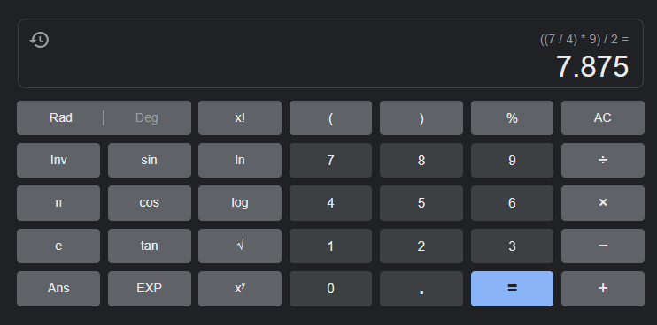

**In java**

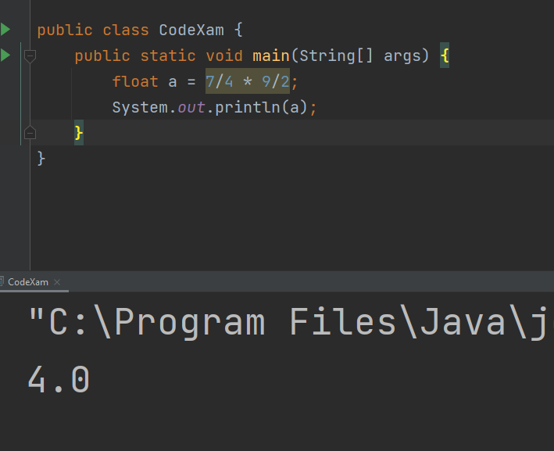

**Approach:**

**So here we did like this for result we need to define the floating point**

**7/4 it always return an integer so 7/4 = 1   
                                Then 9/2 = 4  
                                Then 1*4 = 4 (this is the reason why then   
 Our program return 4 instead of 7.875)**

